|  | **FPT ACADEMY INTERNATIONAL**  **FPT – APTECH COMPUTER EDUCATION** |
| --- | --- |



**Centre Name: ACE-HCMC-2-FPT.**

**Address: 590 Cach Mang Thang 8, District 3, Ho Chi Minh City, Viet Nam.**

Conversion

| **Supervisor.** | Phạm Thị Lánh | |
| --- | --- | --- |
| **Batch.** | T1.2108.A0 | |
| **Group.** | Group 6 | |
| **Serial No.** | **Enrolment Number** | **Student Name** |
| 1. | Student1331704 | Nguyễn Đình Đức |
| 2. | Student1331702 | Hoàng Quốc Vinh |
| 3. | Student1331706 | Huỳnh Thị Xuân Mai |
| 4. | Student1331703 | Đào Đức Minh |

December 2021

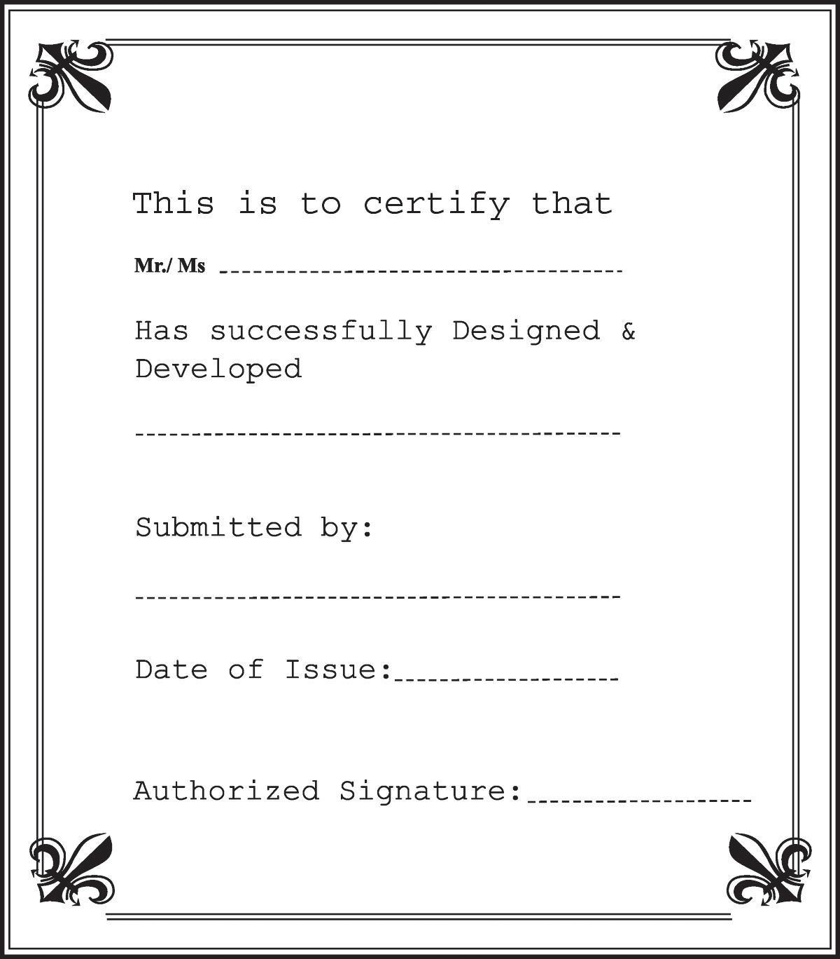

**Contents**

1. **ACKNOWLEDGEMENT 5**
2. **SYNOPSIS 6**
3. **REVIEW 1 7**
   1. **REQUIREMENT SPECIFICATION 8**
   2. **PROBLEM DEFINITION 9**
   3. **CUSTOMERS REQUIREMENT SPECIFICATION (CRS) 9**
   4. **ARCHITECTURE & DESIGN OF THE SYSTEM 12**
   5. **SITEMAP 13**
   6. **WEBSITE LAYOUT 14**
      1. **HOMEPAGE** 14
      2. **CONTACT US** 16
   7. **TASK SHEET 1 18**
4. **REVIEW 2 19**
5. **PROJECT SNAPSHOTS 20**
   1. **Home Page 20**
   2. **Product details Page 21**
   3. **Contact Us: 22**
   4. **Footer 23**
6. **SOURCE CODE WITH COMMENT 23**
7. **USER MANUAL 25**
   1. **System Requirements 25**
   2. **Step by Step Instructions 25**
      1. Starting Home Page: 25
      2. Using Search bars & Dropdown menu 26
      3. Browsing Products Gallery 28
      4. Product Details Page: 29
      5. CTA Buttons – Compare & Download 31
      6. CTA Buttons – Miscellaneous 32
      7. Contact Us 33
      8. Contact Us – Email & Geolocation 33
      9. Footer 34
8. **DEVELOPER’S GUIDE 35**
   1. **Home page 35**
      1. Bootstrap layout 35
      2. Logo Animation 37
   2. **Top Nav Bar 39**
      1. Hamburger Menu 39
      2. Navbar Auto hide on scroll 42
   3. **Side Panel / Side navbar 43**
      1. Search Bar & Searching Algorithm 43
      2. Drop Down Menus 47
      3. Side Panel Responsiveness on smaller screen 51
   4. **Home Page - Hero Banner 52**
      1. Header Text Animation 52
      2. Changing Background Image Animation 55
   5. **Home Page - Main Section 57**
      1. Main Section – Owl Carousel 57
      2. Main Section – Gallery with filter buttons 61
      3. Main Section - Compare & Download Modals 63
   6. **Side Panel Call To Action Modals 69**
   7. **Product Details Page 72**
      1. Youtube embedded promotional videos 72
      2. Product detail section 74
      3. Rating page 76
   8. **Contact Us Page 79**
      1. Contact Us - Hero Banner 79
      2. Contact Us – Feedback & Inquiries 81
      3. Contact Us – Geolocation/Google Map 84
   9. **Footer 85**
      1. Footer – Bootstrap Layout 85
      2. Footer – Lightbox Gallery 88
   10. **Miscellaneous CSS/Animation Modules 92**
       1. Hover.css by Ian Lunn 92
       2. Pin Construction Animation by Nikolay Talanov 93
9. **TASK SHEET 2 94**
10. **CHECKLIST VALIDATION 95**
11. **REFERENCES 96**

# 1 ACKNOWLEDGEMENT

The world is a better place thanks to people who want to develop and lead others. What makes it even better are people who share the gift of their time to mentor future leaders. We would like to acknowledge all those who have given us their support and knowledge sharing in the making of this project.

We wish to express our gratitude to the e-Project Team at the Head Office in India, who provided us with guidance and instructions. We would like to thank all the staff members at the Center in India for providing us the opportunity to work on this project and offering us their utmost encouragement throughout the process.

We would like to express our special thanks to our instructor, Mrs. Pham Thi Lanh at the Aptech Computer Education HCM for her able guidance and support in completing our project. We would also like to extend our gratitude to the staff at the Aptech HCM office for providing us with all the facilities that were required.

Our acknowledgement to several people who also helped with: the collections of pictures samples, CSS & JS libraries, the preparation of web development, sample code snippets ,and tutorials ,and they are all thanked for their contributions. Special mentions go to the contributors of Bootstrap 4, the contributors and admins for tutorials sites such as W3C school, Tutorialspoint.com, GeeksforGeeks, and many other learning sites.

And Lastly, to our many friends and family, you should know that your support and encouragement were worth more than we can express on paper. Thank you to our moms and dads for breakfasts, lunch and dinners – we could not have finished the project without being provided with love and daily nourishments.

# SYNOPSIS

Why does one need metric conversion? Science projects seem more authoritative

when the units used are metric units, such as grams, milliliters, and degrees Celsius.

Anyone can do good backyard science with inches and ounces, but when he shows

his work in a science fair, the metric conversion will show that he understands the

importance of these units to scientists.

There are various units of measurement; one of the earliest types of measurement

concerned with length. Many times we need to convert some data from one unit to

other. Hence you are expected to develop a calculator for such metric conversions.

The website is to be developed for the Windows Platform using HTML5, JavaScript, and Geolocation. The site should work well in all leading browsers including Chrome,

IE, Firefox, etc.

# 

**3. Review 1**

## REQUIREMENT SPECIFICATION

#### The website needs to develop a metric converter that will satisfy the following requirements :

1. There should be a separate web page that displays the metric conversion chart. The chart should include the multiplying factors for the conversion
   * Length conversion:

o Should include the multiplying factors for following

§ Inches millimeters

§ Feet Meters

§ Yards - Meters

§ Miles Kilometers

* + Area conversion

o Should include the multiplying factors for following

§ Square inches Square millimeters

§ Square feet Square meters

§ Square yards Square meters

§ Acres Hectares

§ Square miles Square kilometers

* + Volume conversion

o Should include the multiplying factors for following

§ fluid ounces milliliters

§ gallons liters

§ cubic feet - cubic meters

§ cubic yards - cubic meters

* + Mass conversion

o Should include the multiplying factors for following

§ Ounces grams

§ Pounds kilograms

§ short tons (2000 lb) - mega grams (or "metric ton")

* + Temperature conversion

o Fahrenheit Celsius

o Celsius Fahrenheit

1. There should be separate web pages for the various conversions, you need to include the conversions of
   1. Area
   2. Length
   3. Volume
   4. Mass
   5. Temperature
   6. Currency
2. Along with the above conversion techniques, there should also be information related to all the measurement units as how / who invented them. A brief history about these units should be provided under the separate section as history of measurement units
3. Provide some articles e.g.
   1. The SI System : An article describing what the SI system of units is
   2. Metric System : An article describing the differences between the various metric systems.
   3. The meter An article defining the meter as used in the metric system, both past and present.
   4. Traditional U.S. Units: An article describing the traditional units of measurement used throughout the United States.

1. Also provide the frequently asked questions (FAQs) like
   1. How do I enter numbers in Scientific Notation?
   2. What is a knot? What is a nautical mile?
   3. What about rainfall? How do I convert between inches of rain, and millimeters of rain?
   4. What is the difference between the long ton, short ton, and metric ton?
   5. At what temperature are Celsius and Fahrenheit the same?

## PROBLEM DEFINITION

**Providing the frequently asked questions (FAQs) like:**

1. How do I enter numbers in Scientific Notation?
2. What is a knot? What is a nautical mile?
3. What about rainfall? How do I convert between inches of rain, and millimeters of rain?
4. What is the difference between the long ton, short ton, and metric ton?
5. At what temperature are Celsius and Fahrenheit the same?

## CUSTOMERS REQUIREMENT SPECIFICATION (CRS)

Along with the above conversion techniques, there should also be information related to all the measurement units as how / who invented them. A brief history about these units should be provided under the separate section as history of measurement units

## ARCHITECTURE & DESIGN OF THE SYSTEM

**Provide some articles e.g:**

1. The SI System : An article describing what the SI system of units is
2. Metric System : An article describing the differences between the various metric systems.
3. The meter An article defining the meter as used in the metric system, both past and present.
4. Traditional U.S. Units: An article describing the traditional units of measurement used throughout the United States.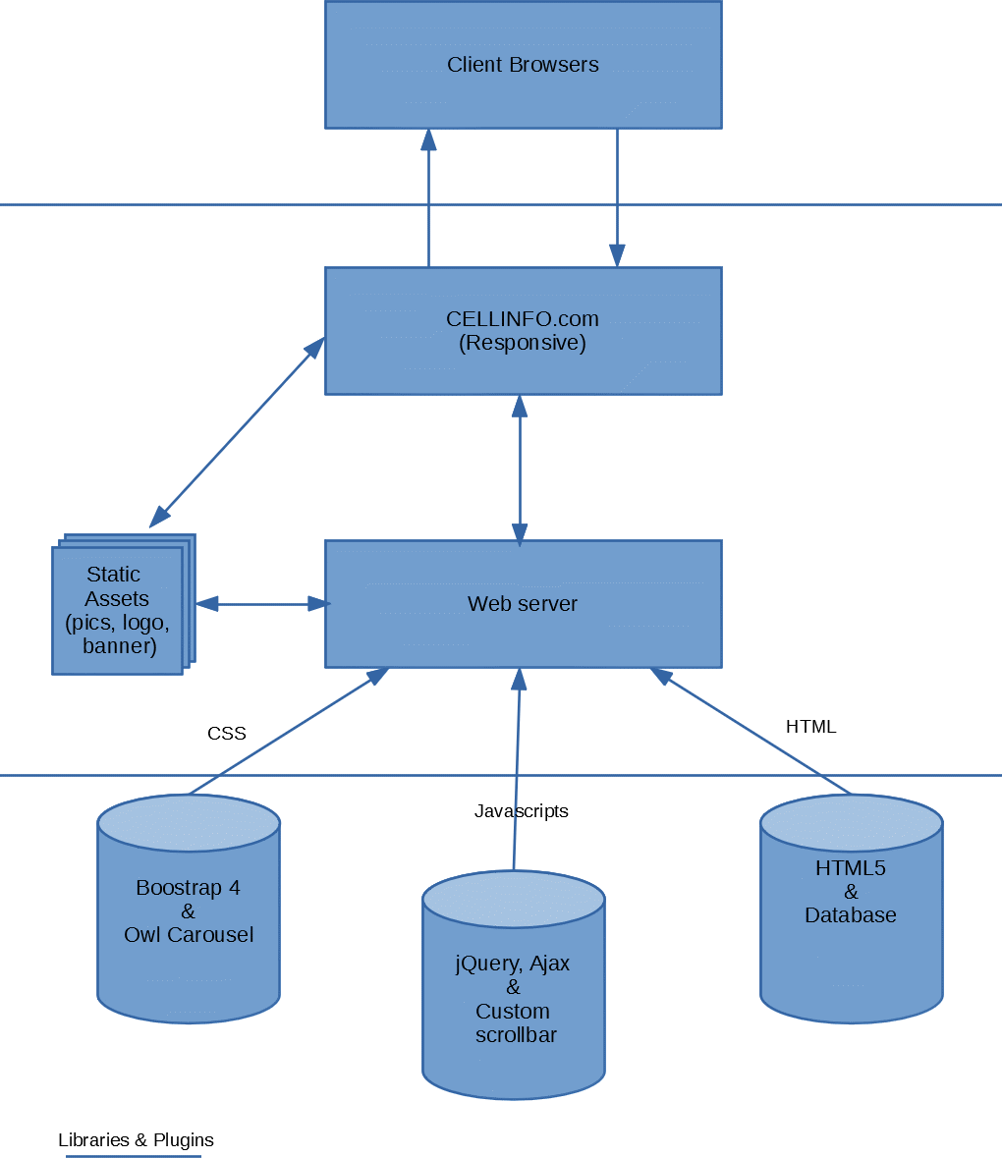

## SITEMAP

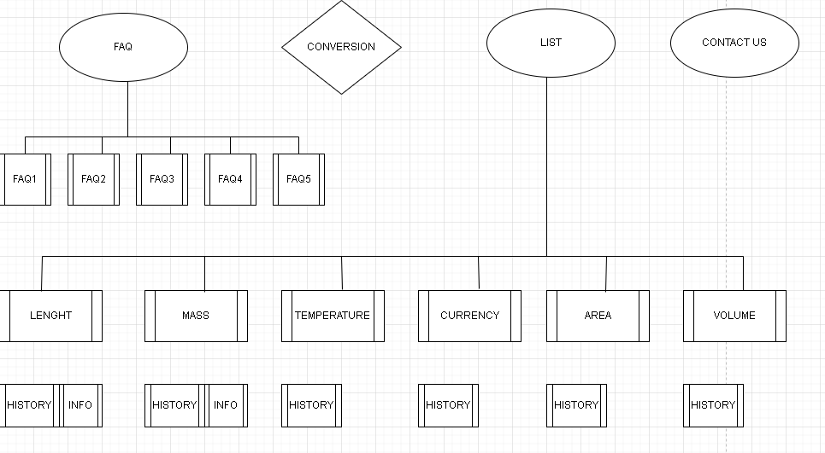

## WEBSITE LAYOUT

The website layout is to be designed with the most realistic one. Because the objective is to provide us with a real-life scenario and help us create basic applications using the tools... The site users will have a variety of interactions such as searching using dropdown list conversion, converting some data from one unit to another, viewing the history of the conversion techniques, and links to third-party websites.

The websites will also have a few pages such as Contact Us which takes customer feedback, containing introductory information about our team and our office address.

### HOMEPAGE

This layout below describes our Home Landing Page which contains two important part:

* **The Top navigation bar:**
* The top bar will have a List conversation button for the side menu (side panel) and Hyperlinks on the right.
* When clicking the List conversion button, a side menu will come out from the left screen side, the side menu is the MOST IMPORTANT part of our project since this is where Users will have the most interactions. There will be several dropdown menus incorporated within buttons to link to other webpage
* **Main Content:**
* A large picture on the front to attract user attention ( there are many pictures on it and you can change to the next picture by clicking on the button next to it)
* Behind that is the About us (which we show you our slogan containing our enthusiasm) and our “dome”

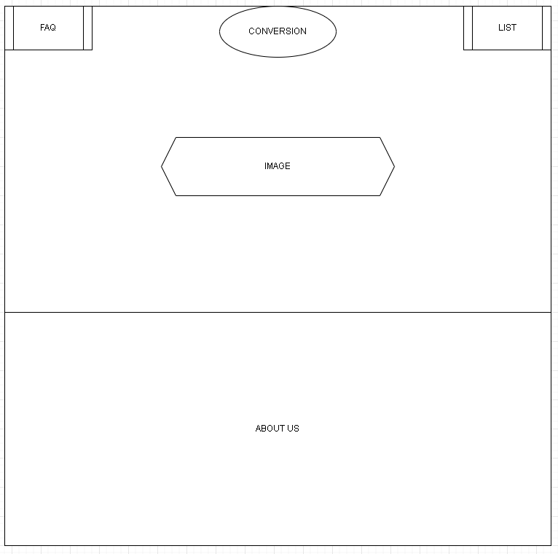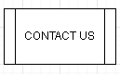

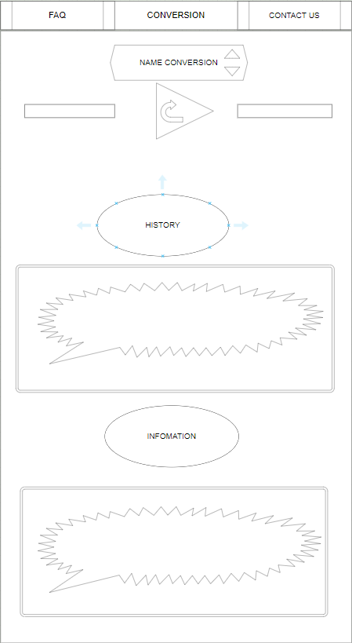

### FAQ

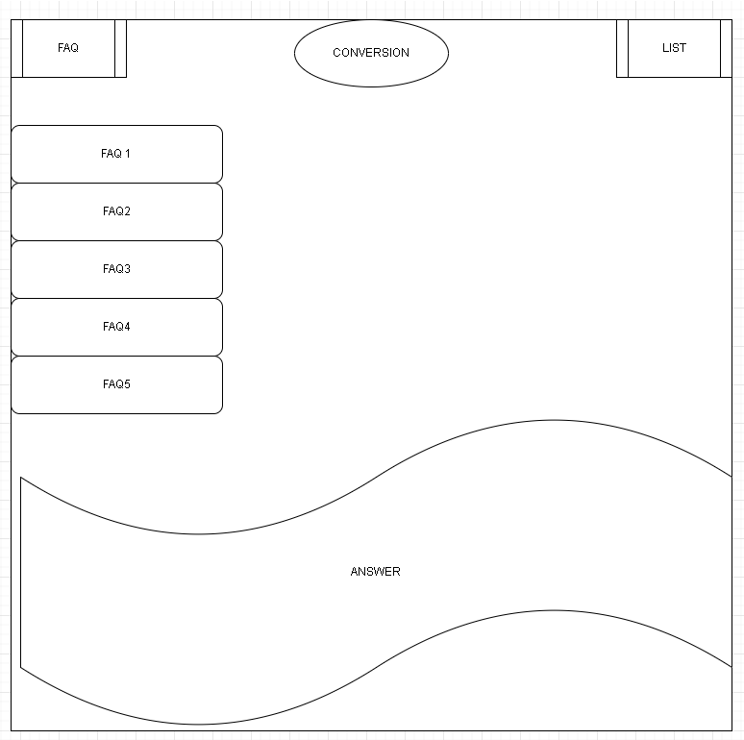

### CONTACT US

The contact us layout will be simple, there will be a main hero banner on top and below are the headings and email link to our office, a feedback form to be populated using Ajax, and our office address along with a geolocation API showing our office location. The topnav menu will become “Active” to show which page users are currently on.

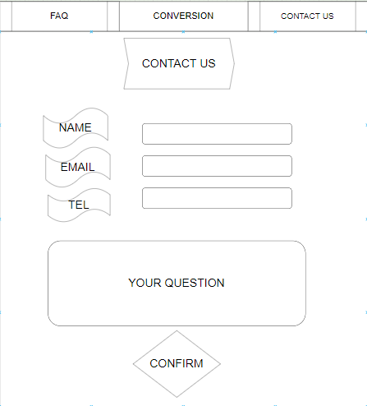

3

## TASK SHEET 1

| **Project Ref No.** | **Project**  **Conversion** | **Activity Plan Prepared**  **by** | **Date of preparation of Activity Plan** | | | |
| --- | --- | --- | --- | --- | --- | --- |
| **Task** | **Actual Start Date** | **Actual Days** | **Teammate Names** | **Status** |
| Brainstorming ideas for  layouts, and Project Objective | | Đức, Vinh,  Mai, Minh | 13/11/2021 | 1 day | N6 | Completed |
| Draw site maps and  architecture design | | Đức, Vinh  Mai, Minh | 13/11/2021 | 1 days | N6 | Completed |
| Wire framing general page  layout. | | Đức, Vinh  Mai, Minh | 14/11/2021 | 2 days | N6 | Completed |
| Collecting information and data (formulas, documents) | | Đức, Vinh  Mai, Minh | 16/11/2021 | 6 days | N6 | Completed |
| Design & Build Home Page | | Đức, Vinh  Mai, Minh | 22/11/2021 | 6 days | N6 | Completed |
| Design & Build Contact Us  Page | | Đức, Vinh  Mai, Minh | 28/11/2021 | 2 days | N6 | Completed |
| Design & Build History Page | | Đức, Vinh  Mai, Minh | 01/12/2021 | 3 days | N6 | Completed |
| Design & Build Information Session | | Đức, Vinh  Mai, Minh | 01/12/2021 | 3 days | N6 | Completed |
| Write project report Review 1 | | Đức, Vinh  Mai, Minh | 04/12/2021 | 3 days | N6 | Completed |

| Signature of Faculty | Signature of Team Leader |
| --- | --- |
|  | **Đức**  Nguyễn Đình Đức |

# REVIEW 2

# PROJECT SNAPSHOTS

## Home Page

The following snapshots illustrate the creation of https://ducn03.github.io/home page:

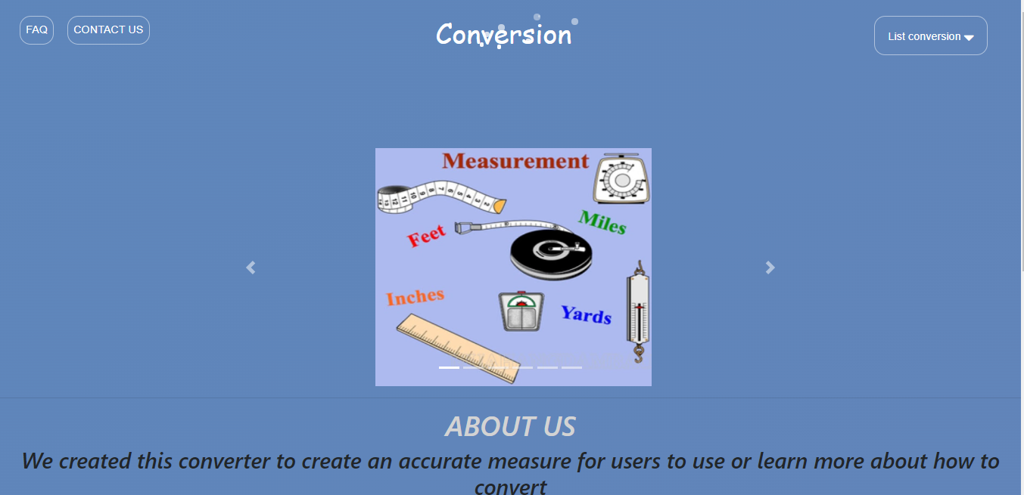

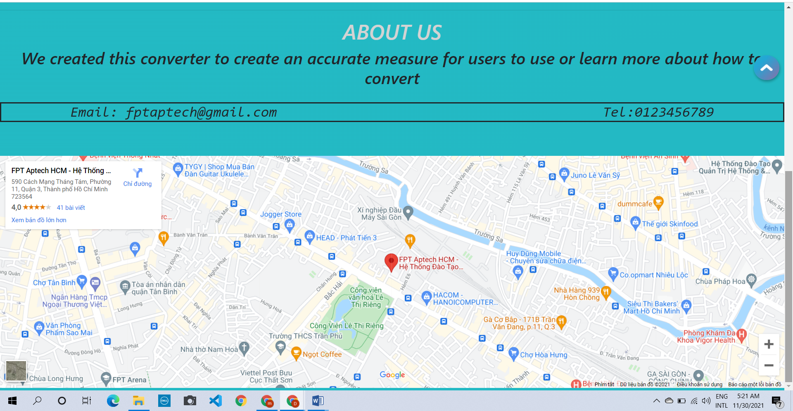

## Product details Page

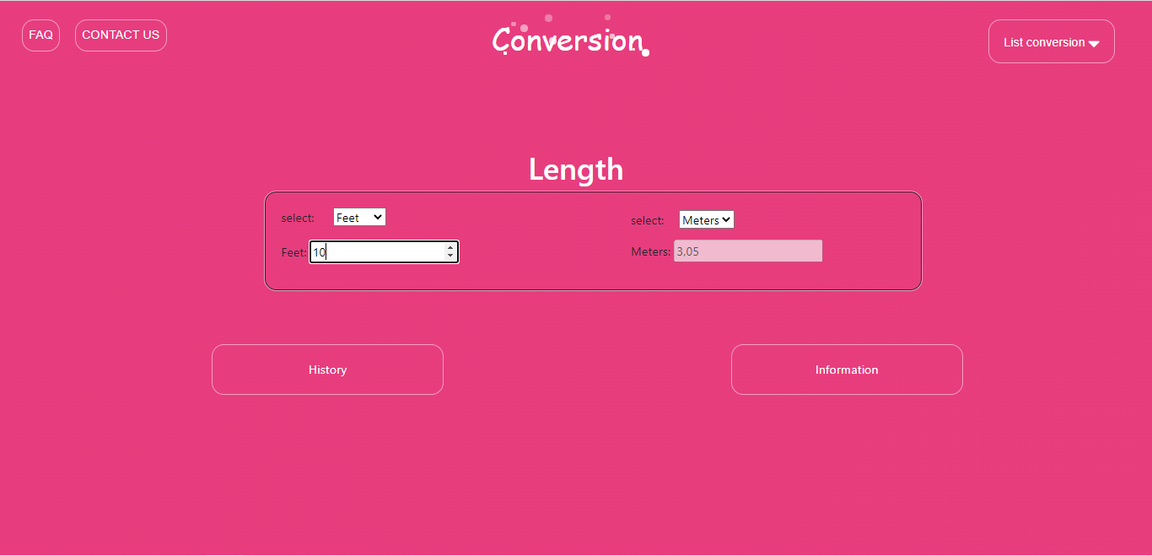

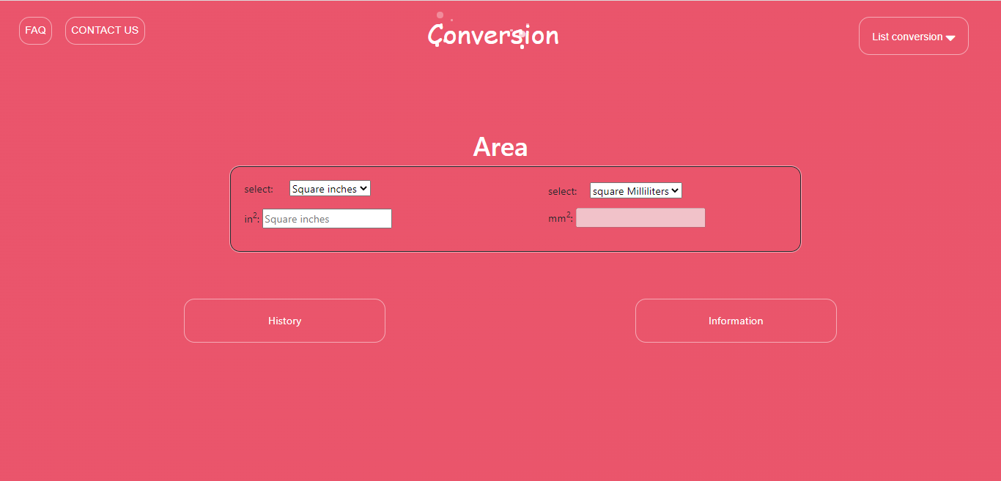

## 

## 

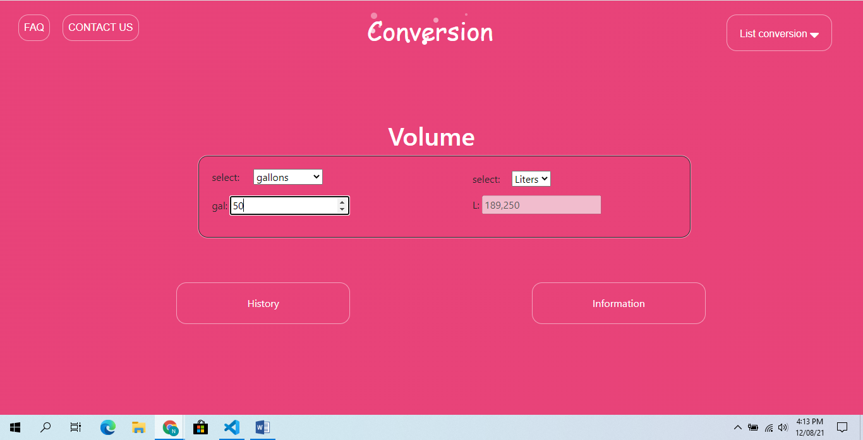

## 

## 

## 

## 

## 

## Contact Us:

The following snapshots illustrate the creation of https://ducn03.github.io/ contact us page: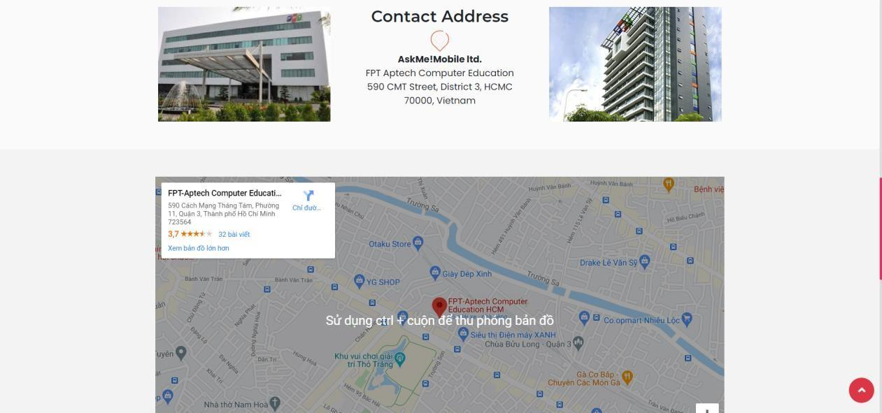

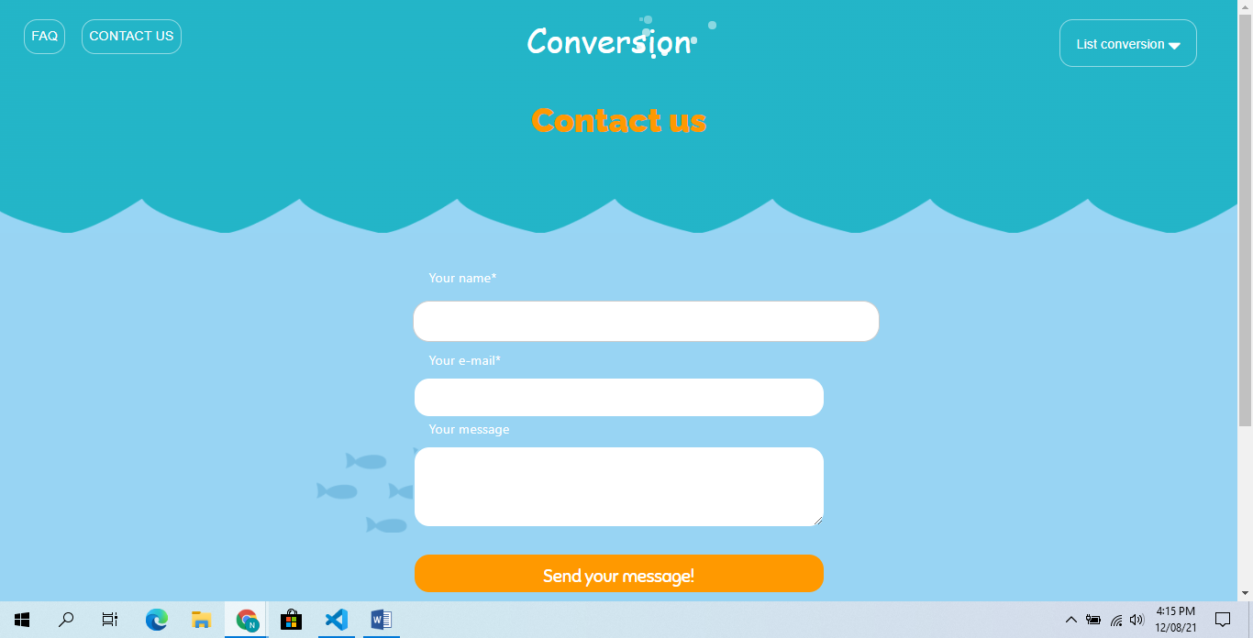

# SOURCE CODE WITH COMMENT

The project is built based upon the Bootstrap 4 framework. However, our developer team also heavily modify this website using custom plug-ins and our own HTML/CSS/JS codes. Below is the illustration of important source codes and libraries that we are using for our project.

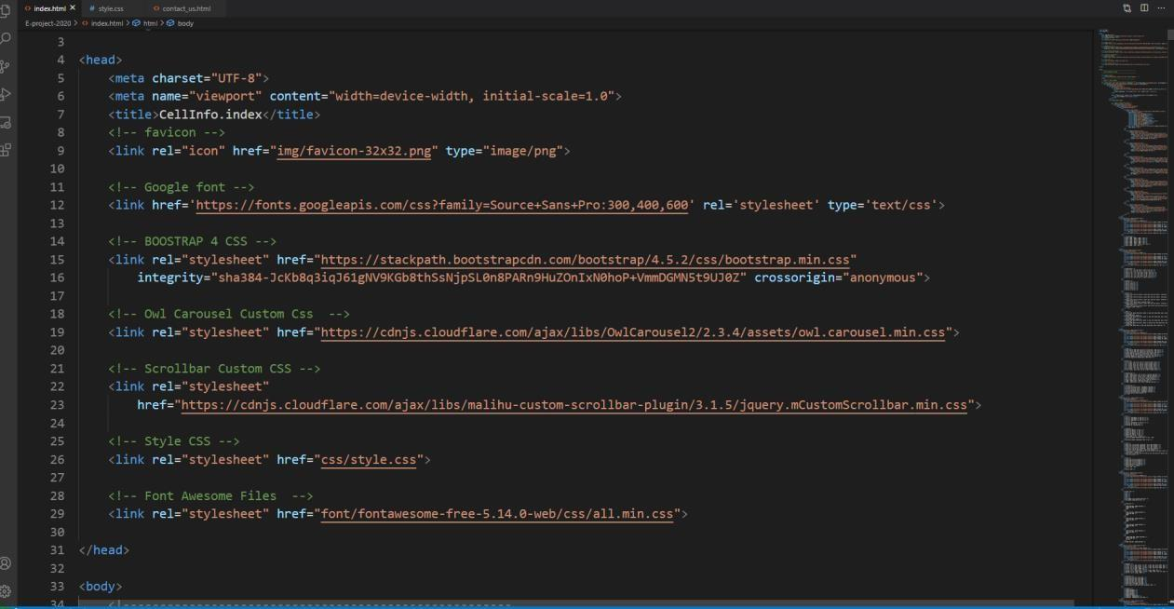

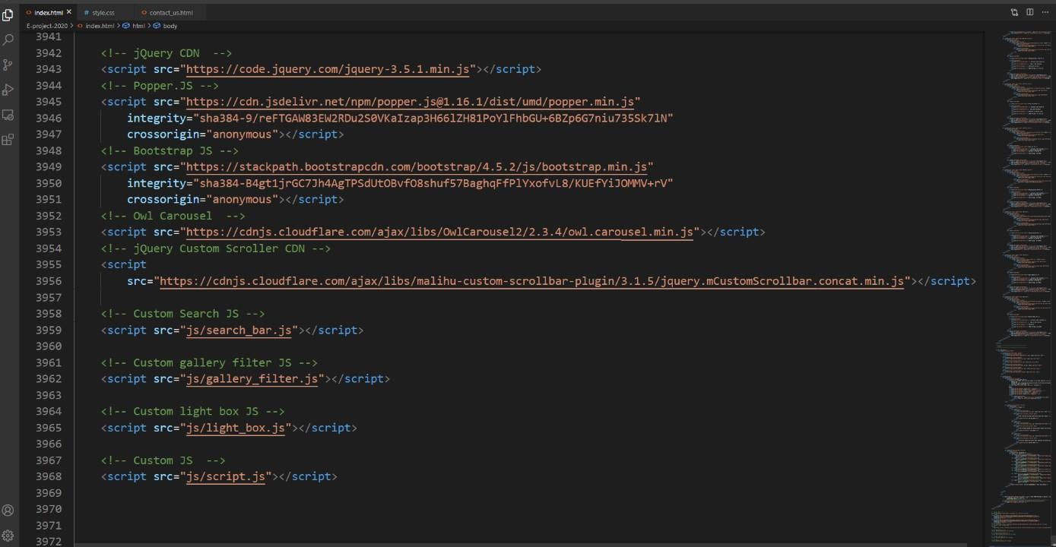

We will go through each module in greater details following our Developer guide.

# USER MANUAL

## System Requirements:

| **No.** | **Items** | **Description** |
| --- | --- | --- |
| 1 | Operating System | Android, iOS, window 7 or higher. |
| 2 | Supporting  Browsers | Chrome, Firefox, Microsoft Edge, IE10+, Opera |

## Step by Step Instructions:

### Starting Home Page:

Users will have access to the website by typing to domain name: <https://ducn03.github.io/Group6_T1.2108.A0.eProject/index.html>. After a brief loading screen user will have access to a top navigation bar and a side menu.

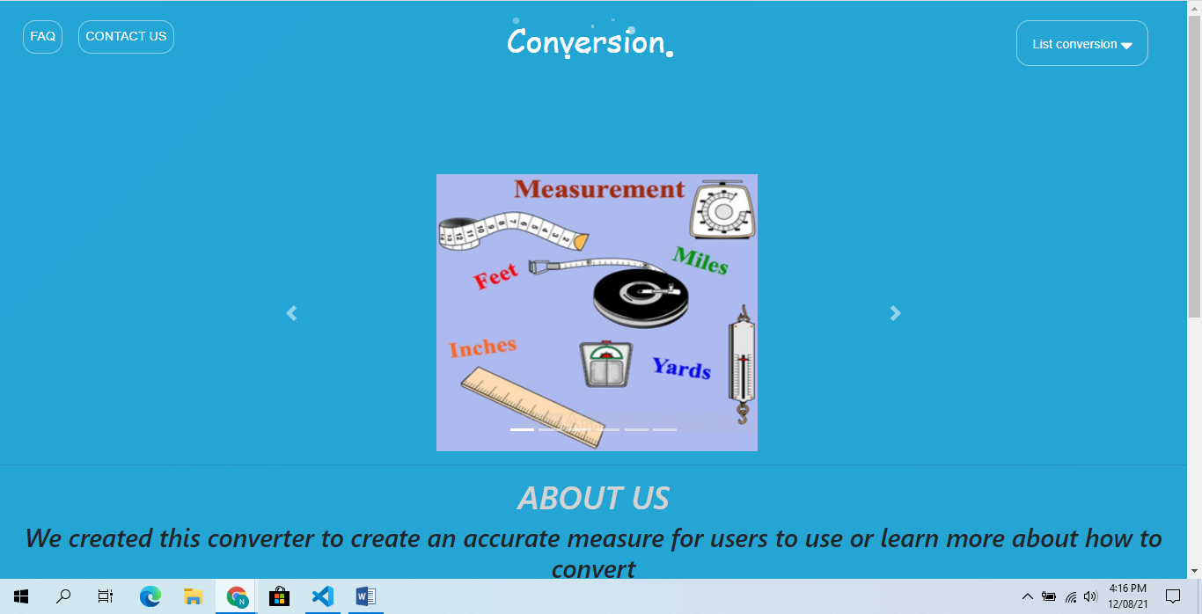

### Using Search bars & Dropdown menu

There are several dropdown menu categorizing metric conversion according to brands and features.

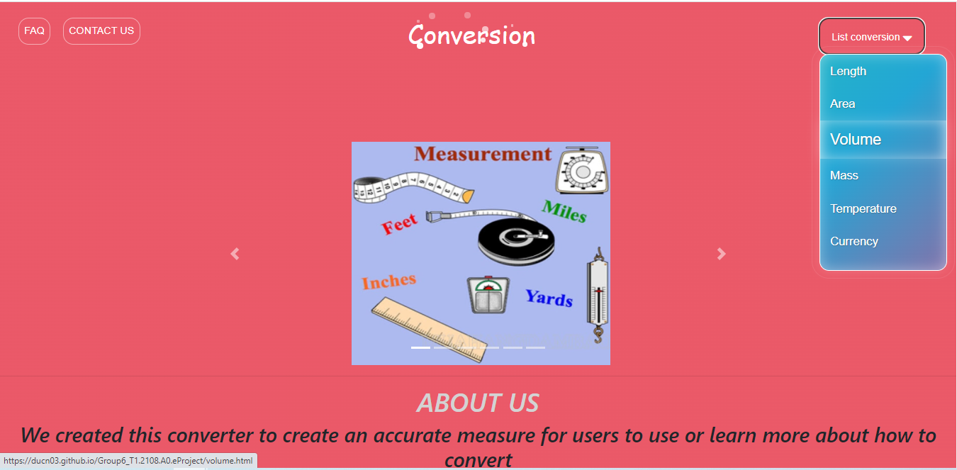

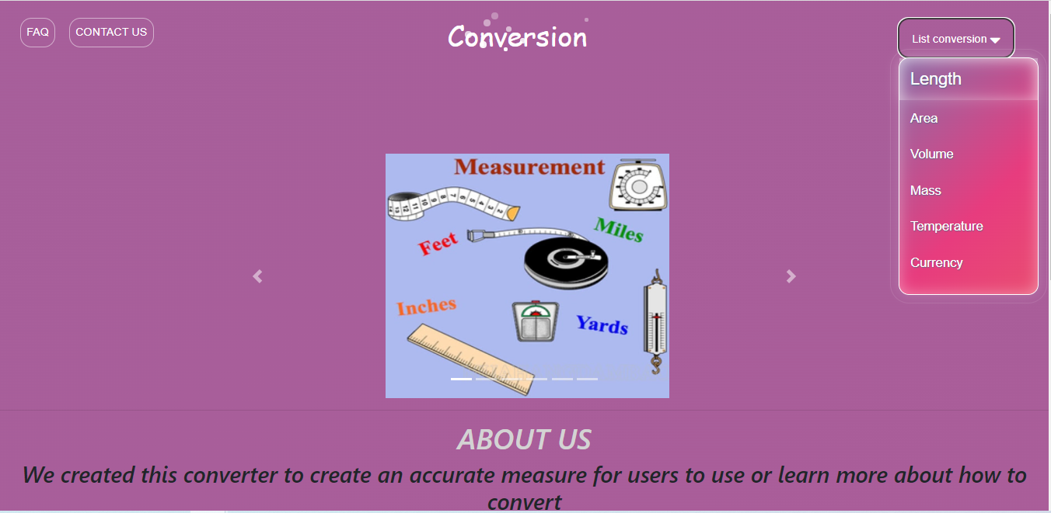

### 

### 

### Email & Geolocation

Our office location can be found at the bottom of the Homepage

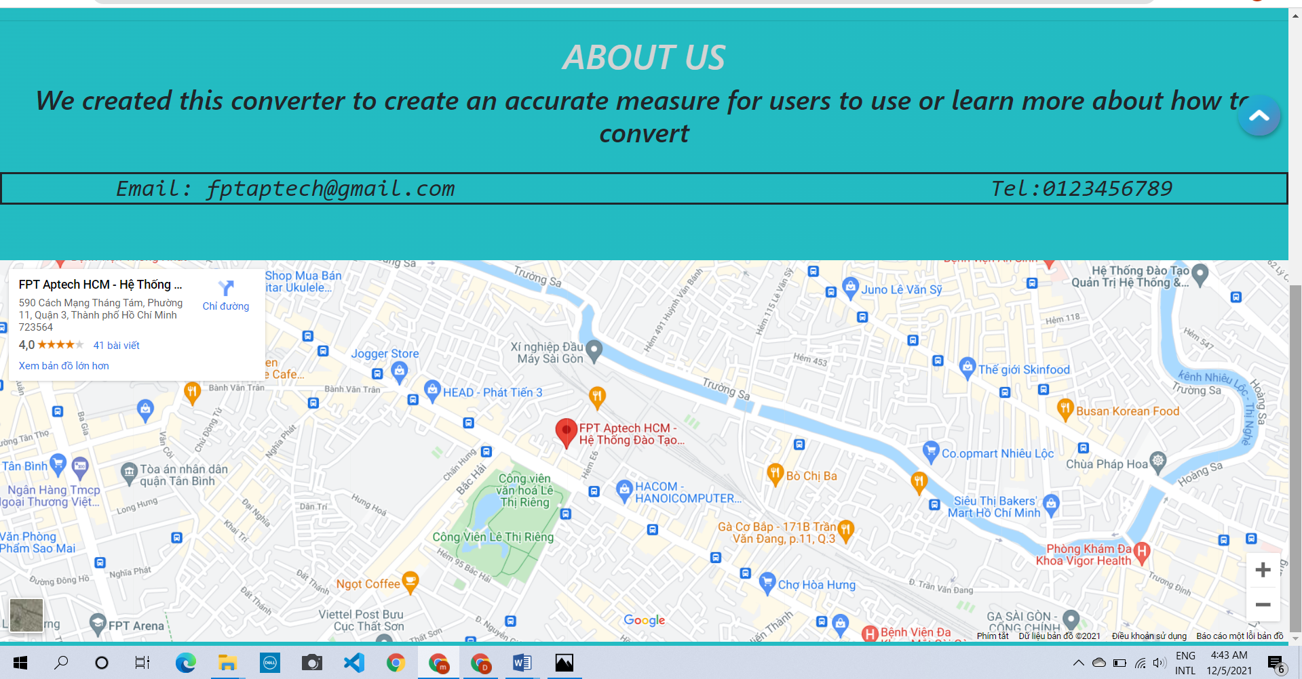

# TASK SHEET 2

| **Project Ref No.** | **Project Title – Ask Me Mobile** | **Activity Plan Prepared**  **by** | **Date of preparation of Activity Plan** | | | |
| --- | --- | --- | --- | --- | --- | --- |
| **Task** | **Actual Start Date** | **Actual Days** | **Teammate Names** | **Status** |
| Brainstorming ideas for layouts and Project Objectives. | | Đức, Vinh,  Mai, Minh | 13/11/2021 | 1 day | N6 | Completed |
| Draw sitemaps and  architecture design. | | Đức, Vinh,  Mai, Minh | 13/11/2021 | 1 days | N6 | Completed |
| Wireframing general page  layout. | | Đức, Vinh,  Mai, Minh | 14/11/2021 | 2 days | N6 | Completed |
| Collecting information and data (formulas, documents) | | Đức, Vinh,  Mai, Minh | 16/11/2021 | 6 days | N6 | Completed |
| Design & Build Home Page. | | Đức, Vinh,  Mai, Minh | 22/11/2021 | 6 days | N6 | Completed |
| Design & Build Contact Us  Page. | | Đức, Vinh,  Mai, Minh | 28/11/2021 | 4 days | N6 | Completed |
| Design & Build About Us  Page. | | Đức, Vinh,  Mai, Minh | 28/11/2021 | 4 days | N6 | Completed |
| Design & Build Information Session | | Đức, Vinh,  Mai, Minh | 01/12/2021 |  | N6 | Completed |
| Design & Build History Page | | Đức, Vinh,  Mai, Minh | 01/12/2021 | 7 days | N6 | Completed |
| Write project report Review 1 | | Đức, Vinh,  Mai, Minh | 04/12/2020 | 3 days | N6 | Completed |
| Testing UI. | | Đức, Vinh,  Mai, Minh | 07/12/2021 | 1 days | N6 | Completed |
| Testing Responsiveness. | | Đức, Vinh,  Mai, Minh | 07/12/2021 | 1 days | N6 | Completed |
| Final Testing. | | Đức, Vinh,  Mai, Minh | 07/12/2020 | 1 days | N6 | Completed |
| Write project report Review 2 | | Đức, Vinh,  Mai, Minh | 07/12/2021 | 1 days | N6 | Completed |

# CHECKLIST VALIDATION

| **Task**  **No.** | **Requirement** | **Validation** |
| --- | --- | --- |
| 1 | The Home Page should be neatly created with proper logo, menu and images. | Yes |
| 2 | A Menu should be created which would show that he understand the importance of these units to scientists. | Yes |
| 3 | The information should be categorized according to are various units of measurement | Yes |
| 4 | A Brief summary of features of measurement should be displayed on the Web Page along with the conversion data but detailed Features should be developed as a calculator for such metric conversions. | Yes |
| 5 | A Comparison Web Page should also be there where there are metric comparisons done with such as grams, milliliters, and degrees Celsius.  Anyone can do good backyard science with inches and ounces, but when they show their work in a science fair, metric conversion will show that they understand the importance of these units to scientists. | Yes |
| 6 | The Comparison information should be provided in Tabular format comparing the features of different units of conversation | Yes |
| 7 | This information would be for 6 types of conversations. | Yes |
| 8 | The Color Schemes should be soothing, more of Pastel Colors can be chosen for the same. | Yes |
|  |  |  |
| 9 | There should be a “Contact Us” page which will have the Address of the Company and the mail address which when clicked will invoke the local mail client from where they can send an email. Address of the Company should be displayed using GeoLocation API (eg.  GoogleMaps) | Yes |
| 11 | Along with the above conversion techniques, there should also be information related to all the measurement units as how / who invented them. A brief history about these units should be provided under the separate section as history of measurement units | Yes |
| 12 | Make use of layers, buttons and modals components of Bootstrap & HTML to avoid creation of html pages. | Yes |
| 13 | Review the appearance and organization of the site. | Yes |
| 14 | Checking Responsive for all browsers. | Yes |

# REFERENCES

* + - 1. Bootstrap 4 Tutorial. <https://www.w3schools.com/bootstrap4/default.asp>
      2. Bootstrap 4 documentation. <https://getbootstrap.com/docs/4.5/getting-started/introduction/>
      3. Jquery API documentation. <https://api.jquery.com/>
      4. W3C Schools code snippets how to. <https://www.w3schools.com/howto/default.asp>
      5. Owl.Carousel.js. <https://owlcarousel2.github.io/OwlCarousel2/>
      6. Hover.css by Ian Lunn. <https://ianlunn.github.io/Hover/>
      7. Stackoverflown: “how to detect escape key with js”. [https://stackoverflow.com/questions/3369593/how-to-detect-escape-key-press-with-pure-js-or-](https://stackoverflow.com/questions/3369593/how-to-detect-escape-key-press-with-pure-js-or-jquery) [jquery](https://stackoverflow.com/questions/3369593/how-to-detect-escape-key-press-with-pure-js-or-jquery)
      8. Smooth scrolling – CSS tricks. <https://css-tricks.com/snippets/jquery/smooth-scrolling/>
      9. Restart css animation – CSS tricks. [https://css-tricks.com/restart-css-](https://css-tricks.com/restart-css-animation/#%3A~%3Atext%3DWhat%20you%20really%20need%20to%2Citself%2C%20then%20remove%20the%20original.%26text%3DThis%20same%20problem%20exists%20for%2Cbut%20then%20again%20on%20%3Ahover) [animation/#:~:text=What%20you%20really%20need%20to,itself%2C%20then%20remove%2](https://css-tricks.com/restart-css-animation/#%3A~%3Atext%3DWhat%20you%20really%20need%20to%2Citself%2C%20then%20remove%20the%20original.%26text%3DThis%20same%20problem%20exists%20for%2Cbut%20then%20again%20on%20%3Ahover) [0the%20original.&text=This%20same%20problem%20exists%20for,but%20then%20again%](https://css-tricks.com/restart-css-animation/#%3A~%3Atext%3DWhat%20you%20really%20need%20to%2Citself%2C%20then%20remove%20the%20original.%26text%3DThis%20same%20problem%20exists%20for%2Cbut%20then%20again%20on%20%3Ahover) [20on%20%3Ahover.](https://css-tricks.com/restart-css-animation/#%3A~%3Atext%3DWhat%20you%20really%20need%20to%2Citself%2C%20then%20remove%20the%20original.%26text%3DThis%20same%20problem%20exists%20for%2Cbut%20then%20again%20on%20%3Ahover)